|  |  |
| --- | --- |
| **Ex.no.4** | **DESIGN OF AN ABSOLUTE LOADER** |
| 17.10.20 |

## Header

#include<stdio.h>

#include<stdlib.h>

#include<math.h>

#include<string.h>

int pack(char , char );

void loader(char [],char [],char []);

## Implementation

#include"head.h"

int pack(char a, char b){

int c,d;

c=a;

c = a-0x30;

if(c>9)

c-=0x07;

d=b-0x30;

if(d>9)

d-=0x07;

c = c<<4;

c+=d;

return c;

}

void loader(char file[],char pgn[],char pgsize[]){

FILE *fp;

char a[50],a1,c,b1,e[50];

char size[10],start[10],h[50],name[10],sz[10];

int len,arr[50],dec,p,i,j,m;

fp = fopen(file,"r");

fscanf(fp,"%[^\n]%c",a,&c);

printf("\n%s\n",a);

if(a[0] == 'H'){

i = 2;

j =0;

while(a[i] != '^'){

name[j++] = a[i];

i++;

}

name[j]='\0';

i++;

j=0;

while(a[i] != '^'){

i++;

}

i++;

while(a[i] != '\0'){

sz[j++] = a[i];

i++;

}

sz[j]='\0';

i++;

if((strcmp(pgn,name)==0)&&strcmp(sz,pgsize)==0)

printf("MEMORY MAP : \n");

else{

printf("Invalid");

exit(0);

}

}

while(!feof(fp)){

if(a[0] == 'T'){

i = 2;

j =0;

while(a[i] != '^'){

start[j++] = a[i];

i++;

}

start[j]='\0';

i++;

j=0;

while(a[i] != '^'){

size[j++] = a[i];

i++;

}

size[j]='\0';

i++;

j=0;

dec = atoi(start);

sprintf(h,"%04X",dec);

while(a[i] != '\0'){

a1 = a[i++];

b1 = a[i++];

p = pack(a1,b1);

sprintf(e,"%02X\n",p);

printf("%s\t%s\n",h,e);

dec ++;

sprintf(h,"%04X",dec);

}

}

fscanf(fp,"%[^\n]%c",a,&c);

}

}

### Application

#include"head.h"

main(int argc,char * argv[]){

char name[10],size[10];

printf("Enter pg name n size\n");

scanf("%s%s",name,size);

loader(argv[1],name,size);

}

### Input File:

H^START^0000^000A

T^0000^03^000009

T^0003^03^180000

T^0006^03^0C000B

T^0009^01^05

E^0000

### Output

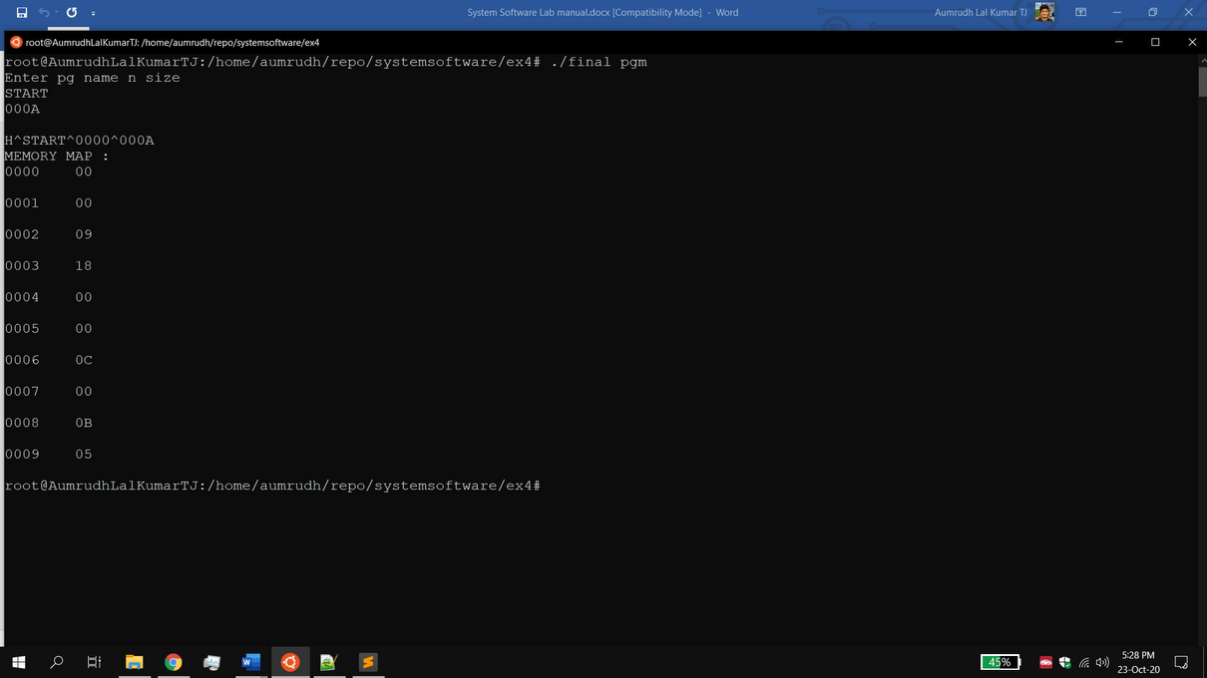

### Result

The absolute loader does memory mapping which is executed successfully.